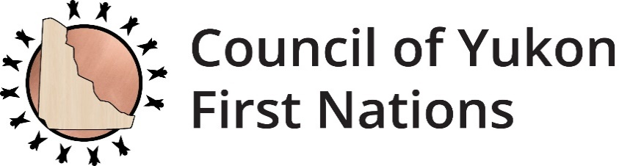



REQUEST FOR PROPOSALS

The Council of Yukon First Nations (CYFN) is seeking Yukon First Nations Artists for 3 separate projects that aim to ensure the Law Centre/Law Courts building is more culturally inclusive. Proponents may submit a proposal for one or more of the 3 deliverables.

A detailed RFP including scope of work, deliverables and evaluation criteria is available on the CYFN website at [www.cyfn.ca](http://www.cyfn.ca).

For more information, please contact:

Chantal Genier, CYFN Senior Justice Analyst

Phone: (867) 393-9200 ext. 9236

Email: Chantal.Genier@cyfn.net

**RFP Deadline:November 24, 2020** **at 4:30 p.m.**

2166-2nd Avenue

Whitehorse, YT Y1A 4P1

867-393-9200

cyfn.ca

**REQUEST FOR PROPOSALS (RFP)**

***Law Centre / Law Courts***

***Yukon First Nations Artwork***

**Description -** This project is a collaboration between CYFN and Government of Yukon, Department of Justice in an effort to make meaningful steps towards reconciliation.

# Request for Proposals

**CYFN Justice Department**

**Issue date: November 3, 2021**

**RFP Deadline: November 24, 2021** **at 4:30 p.m.**

**Contact:**

Chantal Genier, CYFN Senior Justice Analyst

Phone: (867) 393-9200 ext. 9236

Email: Chantal.Genier@cyfn.net

# 

# Timetable:

|  |  |
| --- | --- |
| Issue Date of RFP | November 3, 2021 |
| Submission Deadline | November 24, 2021 |
| Submission Selection Date | December 3, 2021 |

**Scope of Work:**

|  |
| --- |
| This project is a collaboration between CYFN and Government of Yukon Department of Justice in an effort to ensure the Law Centre / Law Courts (Building) located at 2134 -2nd Avenue, Whitehorse Yukon is more culturally inclusive. The project includes 3 separate and distinct projects listed below as the deliverables. |

**The Deliverables:**

|  |
| --- |
| **Atrium Artwork**: Designed by a Yukon First Nations Artist or team for public display in the atrium of the building. The artwork is to be representative of all Yukon First Nations. **Conservation:** Consideration must be given to high levels of light exposure in the location selected therefore light sensitive paints and plastics, colored paper, textiles and ephemeral natural materials may not be appropriate.  **Courtroom 5 Artwork**: Designed by a Yukon First Nation Artist or team for public display in Courtroom 5. The artwork is to be representative of all Yukon First Nations.  **Conservation**: The artwork should either be safe for the public to interact with, or should incorporate some type of barrier to ensure safety of the artwork and the public  **Ceremonial Feathers**: 10 ceremonial feathers including suitable holding/carrying cases for each. The feathers will be distributed as follows: 1 for each of the 5 courtrooms in the building; one for the courtroom in Dawson City; one for the courtroom in Watson Lake; and three to travel with the court party on circuit courts to Yukon communities.  **Installation**: The Atrium Artwork and Courtroom 5 will be installed by and at the expense of Government of Yukon and in collaboration with CYFN and the artist.  **Copyright:** The Atrium Artwork and Courtroom 5 will be an original work and will include copyright of the artist. The artist will grant Government of Yukon a non-exclusive license to use images of the commissioned artwork for the purposes of delivering and promoting government business, programs and services and for use in educational programs. This license will have no end date. Any additional uses will be negotiated to the satisfaction of Government of Yukon and the artist. The license will not affect moral rights for the work, which will be retained by the artist. The fee for copyright licensing described above will be included in this contract. |

## 

## Evaluation/Selection Criteria:

Proposals must demonstrate experience respecting the subject matter and competence to successfully complete the work. Proposals shall include the following:

1. Brief cover letter that demonstrates project understanding and competency to complete the work.
2. A clear description of approach to the deliverables.
3. Detailed project budget including all associated expenses.
4. Profile of the artist(s) or team including qualifications relevant to the needs of this project.
5. A proposed workplan/schedule that shows the work can be completed on time.
6. References (2)

The following is an overview of the categories and weighting for the evaluation and selection criteria of the RFP.

|  |  |  |
| --- | --- | --- |
| **Evaluation/ Selection Criteria Category** | **Weighting (Points)** | **Minimum Threshold** |
| Experience and Qualifications | 20 | 15 |
| Approach to deliverables | 20 | 15 |
| Price | 10 | 7 |
| Yukon First Nations | 5 | 5 |
| **Total Points** | **55** | **42** |

**Experience and Qualifications**

|  |
| --- |
| * Demonstrated experience developing artwork for public display in public spaces; * Examples of past work; * Recognized Yukon First Nations artist and/or Yukon First Nation team; * Demonstrated ability to create artwork representative of all Yukon First Nations; |

## Pricing

|  |
| --- |
| * Budget breakdown detailing professional fees: * Daily / hourly / project rate. * Materials and supplies. * Travel, if required. |

**Yukon First Nations**

CYFN reserves the right to:

* Reject any or all offers and discontinue this RFP process without obligation or liability to any potential Vendor,
* Accept other than the lowest price offer,
* Waive anomalies in proposals, and
* Negotiate with any or all applicants
* Contractor is a Yukon First Nations citizen or business is owned by a Yukon First Nations citizen