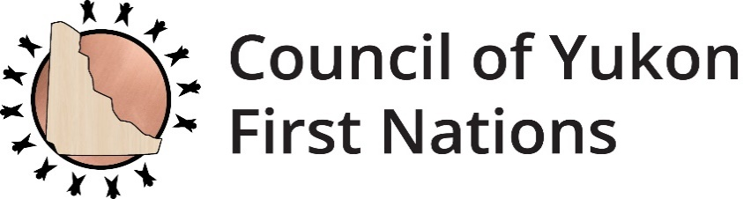



REQUEST FOR PROPOSALS

The Council of Yukon First Nations (CYFN) is seeking a professional accounting firm to provide audit services.

A detailed RFP including scope of work, deliverables and evaluation criteria is available on the CYFN website at [www.cyfn.ca](http://www.cyfn.ca).

For more information, please contact:

Karen Lepine, Director of Finance

Phone: (867) 393-9200 Ext#9209

Email: Karen.lepine@cyfn.net

**RFP Deadline: November 2, 2021** **at 4:30 p.m.**

2166-2nd Avenue

Whitehorse, YT Y1A 4P1

867-393-9200

cyfn.ca

**REQUEST FOR PROPOSALS (RFP)**

***Annual Audit Services***

**Description –**The Council of Yukon First Nations (CYFN) is seeking a professional accounting firm to provide audit services.

# Request for Proposals

**CYFN Finance Department**

**Issue date: October 19, 2021**

**RFP Deadline: November 2, 2021** **at 4:30 p.m.**

**Contact:**

Name: Karen Lepine

Title: Director of Finance

Address: 2166-2nd Avenue, Whitehorse, Yukon, Y1A 4P1

Phone: (867) 393-9200 Ext#9209

Fax: (867) 668-6577

E-mail: karen.lepine@cyfn.net

# Timetable:

|  |  |
| --- | --- |
| Issue Date of RFP | October 19, 2021 |
| Submission Deadline | November 2, 2021 |
| Submission Selection Date | November 8, 2021 |

**Scope of Work:**

|  |
| --- |
| The Council of Yukon First Nations is soliciting proposals from professional accounting firms to provide audit services to our organization for the 3 fiscal years ending March 31, 2024. |

**Deliverables:**

|  |
| --- |
| * + Working directly with finance department staff   + Audit examinations   + Financial recommendations and advice when needed   + Annual attendance and presentation of financial statements at the General Assembly.   + Preparation and filing of annual Corporate Tax for the Revenue Canada Agency |

## 

## Project Timeline:

April 1, 2021 to March 31, 2024

## Evaluation/Selection Criteria:

Proposals must demonstrate experience respecting the subject matter and competence to successfully complete the work. Proposals shall include the following:

1. Brief cover letter that demonstrates project understanding and competency to complete the work.
2. Proposed methodology and workplan.
3. A clear description of services/deliverables included in the project budget.
4. Detailed project budget including all expenses.
5. Profile of the consultant or firm, including project team members and qualifications relevant to the needs of this project.
6. A proposed schedule that shows the work can be completed on time.
7. References (2)

The following is an overview of the categories and weighting for the evaluation and selection criteria of the RFP.

|  |  |  |
| --- | --- | --- |
| **Evaluation/ Selection Criteria Category** | **Weighting (Points)** | **Minimum Threshold** |
| Experience and Qualifications | 20 | 15 |
| Approach | 20 | 15 |
| Price | 10 | 7 |
| Yukon First Nations | 5 | 5 |
| **Total Points** | **55** | **42** |

**Experience and Qualifications**

|  |
| --- |
| * Demonstrated experience of auditing services to non profit organizations. Examples of past work accepted; * Experience with working with Yukon First Nations; * Demonstrated ability to meet deadlines |

**Approach**

|  |
| --- |
| * Detailed work plan with timelines and activities detailing the method of arriving at the deliverables. * Time required to complete the listed deliverables taking into account planning, meeting preparation and facilitation, consolidation of information and preparation of a final draft document. * Demonstrated approach to working with Yukon First Nations. |

## Pricing

|  |
| --- |
| * Budget breakdown detailing professional fees: * Daily / hourly / project rate. * Materials and supplies. * Travel, if required. |

**Yukon First Nations**

CYFN reserves the right to:

* Reject any or all offers and discontinue this RFP process without obligation or liability to any potential Vendor,
* Accept other than the lowest price offer,
* Waive anomalies in proposals, and
* Negotiate with any or all applicants
* Contractor is a Yukon First Nations citizen or business is owned by a Yukon First Nations citizen