Spring into Health Walking Challenge!!! (call the challenge whatever you want)

Did you know that the Yukon Quest is 1,600 kms? So let’s try to walk it and see how far we get!!!
We are doing a walking challenge here at________. The goal is to walk the Yukon Quest Trail (or whatever you chose, you can walk the Dalton Trail, walk to Old Crow etc)! You have 14 weeks (or whatever time you choose) to complete the challenge.

Interested in signing up????
There are weekly prizes and every person who signs up will get a pedometer and a personal tracking sheet (this is optional depending on budget).

At the end of every week, we will put your total number of km walked in a week on the tracking poster in the_________.
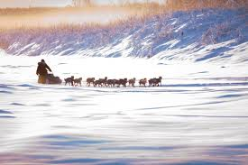
Sign up by talking to __________
The challenge will start ________________________________
Walking Challenge Instructions

- Wear your pedometer all the time (except when you shower and sleep ☺ ) At the end of every day, write down how many steps you took. If you want to log your steps online, an option is to join the on the right path challenge through the Recreational and Parks Association of Yukon (www.ontherightpath.ca)
- At the end of every week (SUNDAY), add up all of your steps and then email me on Monday morning to let me know what the total is and I will write it on the poster. The poster is up ________.
- The goal is to walk the distance of the Yukon Quest trail – 1600 kms.
- That is it.

You can walk in groups, walk solo, jog, do stairs, even ride a bike. Whatever floats your boat. The point is to get moving and challenge yourself to be more active. Exercise has so many benefits, especially when it is paired with a healthy diet too (free of refined sugar and processed food).

Note: if you don’t have pedometers to distribute to all the staff, then use the following metrics:

