Let’s go on a Smoothie Vacation!

Join us in Health and Social on ___________
at 10 am for healthy smoothies and fun times

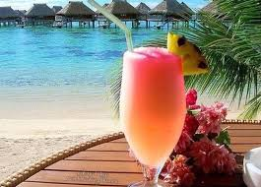

(indicate whether you will be charging for the smoothies)

For more information, call _________________

