Salad Bar!
Make your own salad lunch

Join us for a healthy salad lunch in Health and Social on ____(insert date)_______

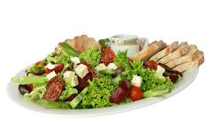

(indicate whether you will be charging for the salad)

For more information, call _________________

