Walk to the OC with me!!!
Fall Walking Challenge
September 6-November 25
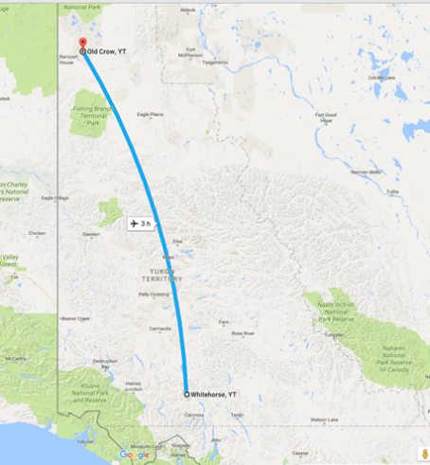
Did you know that Old Crow is almost 800 km away from Whitehorse?

So let’s walk there!!

We are doing a walking challenge here at CYFN. The goal is to walk to Old Crow…800 kms! You have 12 weeks to complete the challenge.
That works out to about 9,500 steps or 9.5 km a day. You would be amazed how fast your steps add up
Did you know that most people in an office setting spend 60% of their work day seated, and that sitting for prolonged periods of time has adverse health effects that are worse than SMOKING?!!! (link is here)
Interested in signing up????
There are weekly prizes. Most people will have a pedometer already, but if you don’t, I have a couple.

At the end of every week, your total number of km walked in a week on the tracking poster in the kitchen. I will send more detailed instructions once everyone has signed up.

Sign up by talking to Reanna

The challenge will start September 6th and run through til November 25th

