Activity #3 - Egg Drop Challenge
The purpose of this game is to build staff morale and encourage a little bit of friendly competition. You need two (or more) teams of 2 or more people to play this game. You can mix staff up or make it a competition between departments.
The objective of this challenge is to design a container that will prevent an egg from cracking or breaking when it is dropped from a high fall. This can be as complex or as simple as teams want to make it.

Materials needed (pick and choose, you don’t need to include all the materials)
- Raw eggs
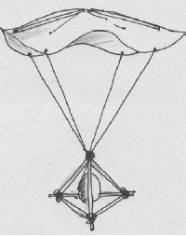
- Toilet paper rolls
- Newspaper
- Shoebox
- Popsicle sticks
- Tape
- Rubber bands
- Plastic bag
- String
- Balloons
- Packing peanuts

Instructions
- With your teammates, design and make a protective container to protect an egg from a high fall. Use only the materials that are provided. Give teams 15 minutes to construct their containers
- Taking turns, drop the container from somewhere high.
- After you drop it look and see if your egg cracked or remained intact. (Remember to wash your hands after touching raw egg!)

Alternative
Use only natural materials (branches, sticks, leaves, rocks etc) to construct your egg protector.

