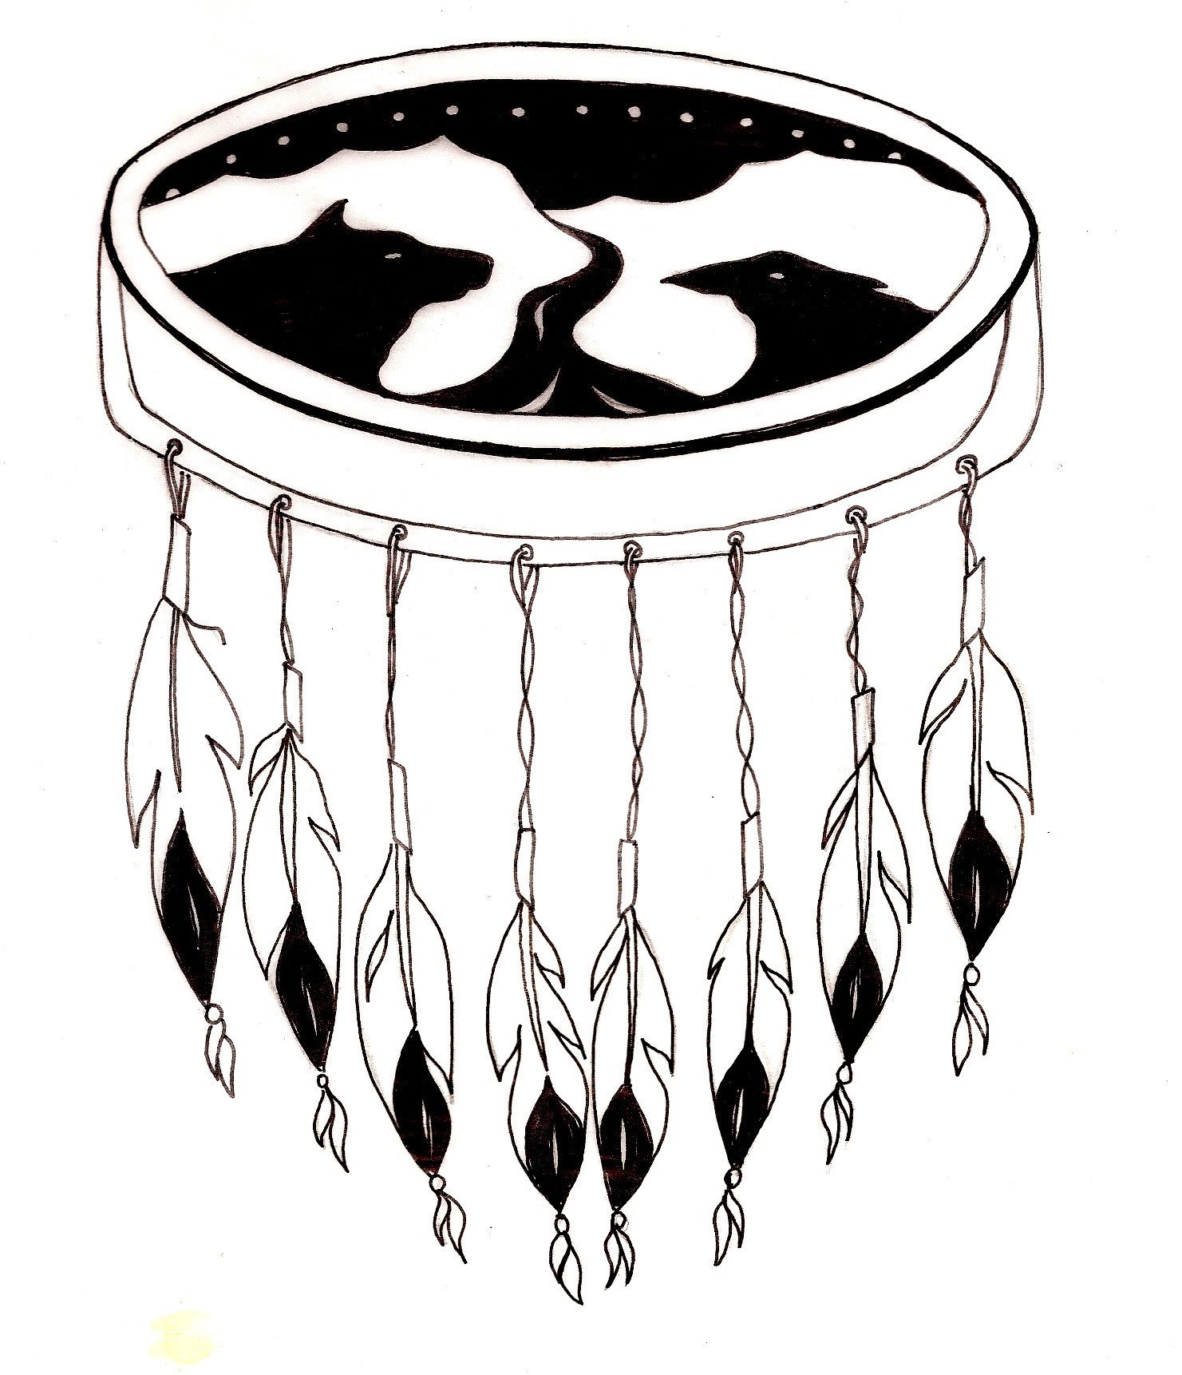

First Nations Programs & Partnerships

Our Stories of Residential Schools in Yukon and Canada: Seeking Understanding, Finding our Way Together. Inservice held September 30 to October 1, 2014 in Whitehorse, Yukon.

Thank you to Councilor Jessie Dawson for her welcome on behalf of Kwanlin Dun First Nation.
Thank you to the Honorable Minister Elaine Taylor for her welcome and attendance at the in-service.
Heartfelt appreciation to to our Elders Dorothy Smith, Mary Battaja, Liz Hall, Chuck Hume, and Sam Johnston for guiding us through the process and sharing their wisdom in the presentations.
Very special acknowledgementsto all the former students and intergenerational survivors who were courageous in sharing experiences at the in-service and who helped create some of the resources included in the grade 10 kit and whose history we are learning about. Mahsi cho to the Kanacha group for the book, “Finding Our Way Home” which we are using as a student resource.
Special thanks to all the First Nations Programs and Partnerships Unit and Curriculum staff who were presenters for the sessions: Sharon Shadow, Barbara Hobbis, Pat Joe, Rene Dove, Christopher Cox, Debbie Gohl, Liz Woods and Yukon College staff, First Nations Initiatives: Davida Wood and Cassandra Ivany ; and Lori Eastmure. Very special thanks to Rene Dove who created the entire Socials 10 kit throughout the past year using input from all the working groups. Thank you to Ruby Grant for supporting the in-service. Thank you to our FNPP colleague, Danielle Sheldon who was not able to attend but was in our thoughts.
Thank you to CYFN Education Department Tina Jules and Jennifer Wykes for attending and organizing the travel for the CELC/ESW’s: Alma Wrixon, Julia Joe, Lenora Minet, Linnea Rudachyk, Bessie Chasse, Donna Ward, Jennifer Chambers, Evelyn Troy, Joanie Acklack, Joanne Buyck, Stan Njootli and Glenna Tetlichi.
Thank you to Health Canada who partnered with CYFN to facilitate the health support training: Christian Dutil, Pam Schmid, Hazel Buffalo-Robe, Lori Duncan, Ingrid Isaac and Jackie MacLaren. Thank you to the Health Support Workers: Joanne Henry, Jackie Johnny, Mary Rose Sydney, Victor Stewart, Vern Swan, Rose Caesar, Joe Tetlichi, , Esther Dobbs, Eileen Fields, Joseph Graham, Cathy Samson, Vera Charlie, Mary Jane Smith, Lynn Rear, Lena Joe, Ragu Kolothumkattil, and Carol Shorty. Thank you to the YFN who attended: Roy Dick, Helen Loots, Isabelle Dewhurst, Jodi Beaumont, Ann Maje Raider, and Travis Stewart.
Thank you to all the teachers and counsellors who attended: Logan Wedge, Linda Hamilton, Pierce Butler, Donna Letang, Mario Magon, Paul McFadyen, Linda McDonald, Robert Hotson, Shannon Washburn- Hayden, Vernon Asp, Flora Asp, Lauren Baranik, Marcia LaLonde, Bill Willoughby, Ken Symanski, Rosemary Buck , Chris Hobbis, Carolyn Coombs, Peter Grundmanis and Sean Wilkinson. Thank you to the Gadzoosdaa staff: Shereen Hill, Dan Pearson, and Lynn Brown.
We are finding our way together, thanks to all of you.
Janet McDonald,
Director, First Nations Programs and Partnerships Unit
Public Schools Branch
Yukon Education

Màhsi’ choo (Gwich’in) Mhsi’ cho (Hän)
Máhsin cho (Northern Tutchone) Tsin’ choh (Upper Tanana)
Shw níthän (Southern Tutchone) Sógá sénlá’ (Kaska)
Gunałchîsh (Tlingit) Gùnèłchīsh (Tagish)


