 | FIRST NATIONS EDUCATION COMMISSION
6/17/2014 | FNEC ANNUAL REPORT 2013-14
 | The First Nations Education Commission was reinstated through Leadership Resolution on April 23, 2013.

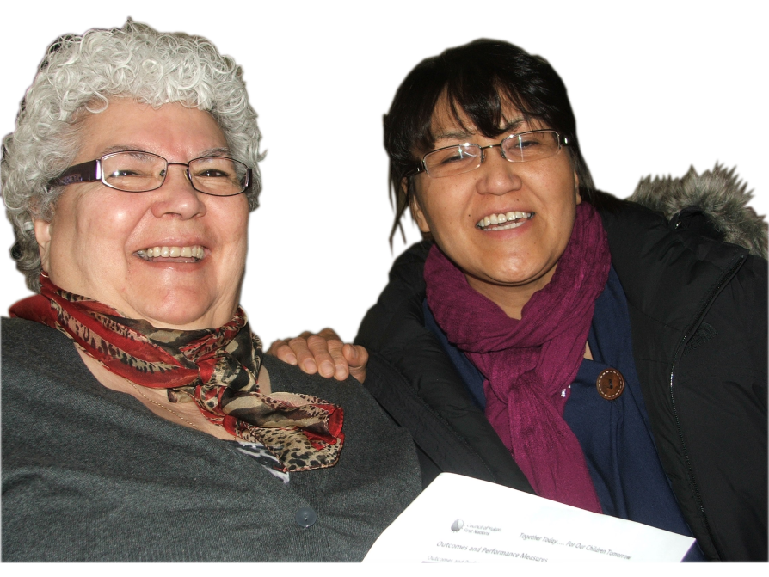
FIRST NATIONS EDUCATION COMMISSION
Figure 1 FNEC officials, ingrid johnson, education director and julia joe, celc, selkirk first nation

FNEC ANNUAL REPORT 2013-14

Background
The FNEC was re-established in April of 2013 by resolution from the YFN Leadership. The Commission’s co-chairs were Tosh Southwick, KFN and Shandell McCarthy, CAFN with Vera Owlchild, CAFN and Roberta Hager, FNNND serving as alternate co-chairs, however Shandell is freeing herself up for other endeavors in life. FNEC officials wish her all the best in her pursuit of higher education.
The following First Nations are members of the FNEC:
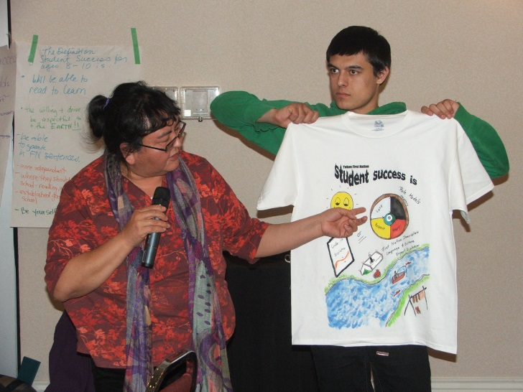
1. Carcross Tagish First Nation, Geraldine James
2. Champagne and Aishihik First Nations, Shandell McCarthy (Vera Owlchild, alternate)
3. First Nation of Na-Cho Nyak Dun, Roberta Hager
4. Kluane First Nation, Tosh Southwick (Kluane Adamek, alternate)
5. Liard First Nation, Helen Loots (alternate)
6. Little Salmon Carmacks First Nation, Shelby Blackjack
7. Selkirk First Nation, Ingrid Johnson (Julia Joe, alternate)
8. Teslin Tlingit Council, Tim Cant (Robin Smarch, alternate)
9. Tr’ondek Hwech’in First Nation, Ashley Doiron (Lynn Rear, alternate)
10. Vuntut Gwitch’in First Nation, Margaret Smith (Jeremy McCullough, alternate)
11. White River First Nation, Douglas Joe
12. Council of Yukon First Nations, Tina Jules
Figure 2FNEC official roberta hager at the yfn student success workshop with youth, ashton arcand

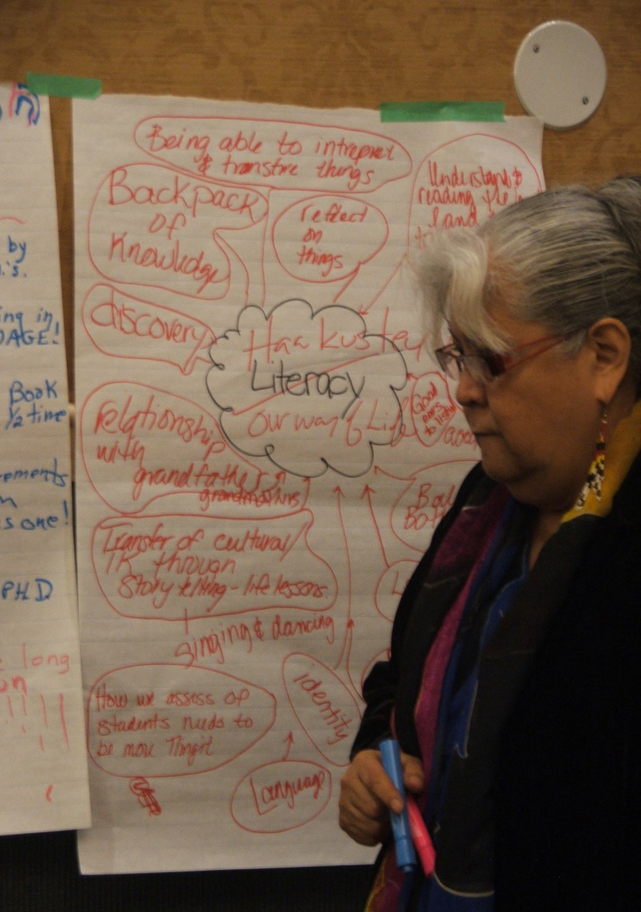
An overview of the Commission’s Terms of Reference is as follows:
Provides advice and recommendations to YFN Leadership on education matters and has a scope of lifelong learning. The commission works on education matters including early childhood education, primary and secondary education, post-secondary education and employment training.
MANDATE
•Provide technical support, advice and recommendations to YFN members of FNEC with respect to education matters;
•Work to implement the YFNs’ authority with respect to education matters;
•Promote collaboration amongst YFNs, governments and institutions with respect to education matters;
•Identify areas of common interest and concerns to YFNs related to education, including programs, standards and measures;
•Facilitate the development and delivery of culturally-appropriate education systems, programs, services; and
•Promote the development of internal capacity within YFNs relating to education matters.
The Commission met on the following dates in 2013-14:
Figure 3 fnec official, geraldine james, ctfn capacity development director
August 8th, 2013
October 1st and 2nd, 2013
December 4th and 5th, 2013
February 12th and 13th, 2014
May 21st and 22nd, 2014
June 17th to the 19th, 2014
The Commission had representation at the following education events in 2013-14:
YFN Literacy Framework Development Workshop – January 22-24, 2014
YFN Student Success Workshop – February 18-20, 2014
YFN Education Summit: Joint Education Action Plan - March 4-6, 2014
FNEC & Yukon Literacy Strategy Working Group Joint Meeting – May 21st, 2014
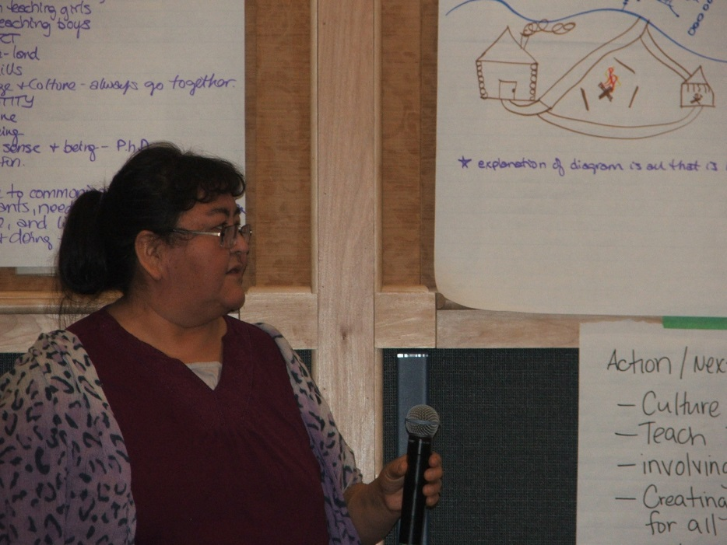
Figure 4: chair of MOU Joint education action plan working group and FNEC's
alternate co-chair, roberta Hager, FNNND Education manager
During the December 2014 meeting, the FNEC identified its priorities and will be developing a strategic plan, funding pending. This work will continue over the 2014 year. On an on-going basis, the Commission deals with many education issues and concerns as relates to YFN education. During meetings, the Commission puts forward strategies and recommendations aimed at advancing YFN education; improving student learning outcomes for YFN students and improving the involvement and engagement of YFN students, parents, families and communities in the school system.
The Commission has reviewed, provided feedback, advice and guidance for the following CYFN Education initiatives:
- YFN Literacy Framework
- YFN Student Achievement Reports – “How are we doing?”
- YFN Joint Education Action Plan
The Commission has reviewed, provided advice and is considering engagement protocol and consultation processes as it relates to the following Yukon Department of Education initiatives:
- Yukon Literacy Strategy
- Rural Education Strategy
The Commission has identified the numerous boards, committees and councils as a priority that needs to be addressed in order to increase effectiveness, reduce duplication and maximize resources. In other cases, the Commission provides First Nation representation on a number of Department of Education committees such as:
- YFN Education Advisory Committee
- Rural Strategy Committee
- Transitions to Adulthood Committee
- Bullying Committee

